VISVESVARAYA TECHNOLOGICAL UNIVERSITY

“JnanaSangama”,Machhe,Belagavi,Karnataka-590018

Lab Experiment Record
Project Management with Git [BCSL358C]
SubmittedinpartialfulfillmenttowardsAECof3rdsemesterof

Bachelorof Engineering

in
ComputerScienceandEngineering
(ArtificialIntelligence&MachineLearning)

Submittedby
TELUGU SHIVANI

4GW24CI057

DEPARTMENTOF CSE(ArtificialIntelligence&MachineLearning)
GSSS INSTITUTE OF ENGINEERING & TECHNOLOGY FOR WOMEN

(AffiliatedtoVTU,Belagavi,ApprovedbyAICTE,NewDelhi&Govt.ofKarnataka)
K.R.SROAD,METAGALLI,MYSURU-570016,KARNATAKA

(AccreditedbyNAAC)

2025-2026

INDEX
SR.NO. | CONTENTS | Page No.
1. | Syllabus | 3
2. | Git Life Cycle | 5
3. | Git Configuration | 10
4. | Experiment 1 | 11
5. | Experiment 2 | 14
6. | Experiment 3 | 17
7. | Experiment 4 | 19
8. | Experiment 5 | 21
9. | Experiment 6 | 23
10. | Experiment 7 | 24
11. | Experiment 8 | 25
12. | Experiment 9 | 26
13. | Experiment 10 | 27
14. | Experiment 11 | 28
15. | Experiment 12 | 30
SYLLABUS

- Setting Up and Basic Commands
Initialize a new Git repository in a directory. Create a new file and add it to the staging area and commit the changes with an appropriate commit message.

- Creating and Managing Branches
Create a new branch named "feature-branch." Switch to the "master" branch. Merge the "feature-branch" into "master."

- Creating and Managing Branches
Write the commands to stash your changes, switch branches, and then apply the stashed changes.

- Collaboration and Remote Repositories
Clone a remote Git repository to your local machine.

- Collaboration and Remote Repositories
Fetch the latest changes from a remote repository and rebase your local branch onto the updated remote branch.

- Collaboration and Remote Repositories
Write the command to merge "feature-branch" into "master" while providing a custom commit message for the merge.

- Git Tags and Releases
Write the command to create a lightweight Git tag named "v1.0" for a commit in your local repository.

- Advanced Git Operations
Write the command to cherry-pick a range of commits from "source-branch" to the current.

9. Analysing and Changing Git History

Given a commit ID, how would you use Git to view the details of that specific commit, including the author, date, and commit message?

10. Analysing and Changing Git History
Write the command to list all commits made by the author "JohnDoe" between "2023-01-01" and "2023-12-31."

11. Analysing and Changing Git History
Write the command to display the last five commits in the repository's history.

12. Analysing and Changing Git History
Write the command to undo the changes introduced by the commit with the ID "abc123".

Git Life Cycle

The Git lifecycle refers to the typical sequence of actions and steps you take when using Git to manage your source code and collaborate with others. Here's an overview of the Git lifecycle:

- Initializing a Repository:
To start using Git, you typically initialize a new repository (or repo) in your project directory. This is done with the command git init.

2. Working Directory:
Your project files exist in the working directory. These are the files you are actively working on.

3. Staging:
Before you commit changes, you need to stage them. Staging allows you to select which changes you want to include in the next commit. You use the git add command to stage changes selectively or all at once with git add.
.
4. Committing:
After you've staged your changes, you commit them with a message explaining what you've done. Commits create snapshots of your project at that point in time. You use the git commit command to make commits, like git commit –m "Add new feature".

5. Local Repository:
Commits are stored in your local repository. Your project's version history is preserved there.

6. Branching:
Git encourages branching for development. You can create branches to work on new features, bug fixes, or experiments without affecting the main codebase. Use the git branch and git checkout commands for branching.

- Merging:

After you've completed work in a branch and want to integrate it into the main codebase, you perform a merge. Merging combines the changes from one branch into another. Use the git merge command.

- Remote Repository:
For collaboration, you can work with remote repositories hosted on servers like GitHub, GitLab, or Bitbucket. These repositories serve as a central hub for sharing code.

- Pushing:
To share your local commits with a remote repository, you push them using the git push command. This updates the remote repository with your changes.

- Pulling:
To get changes made by others in the remote repository, you pull them to your local repository with the git pull command. This ensures that your local copy is up to date.

- Conflict Resolution:
Conflicts can occur when multiple people make changes to the same part of a file. Git will inform you of conflicts, and you must resolve them by editing the affected files manually.

- Collaboration:
Developers can collaborate by pushing, pulling, and making pull requests in a shared remote repository. Collaboration tools like pull requests are commonly used on platforms like GitHub and GitLab.

- Tagging and Releases:
You can create tags to mark specific points in the project's history, such as version releases. Tags are useful for identifying significant milestones.

- Continuous Cycle:
The Git lifecycle continues as you repeat these steps over time to manage the ongoing development and evolution of your project. This cycle supports collaborative and agile software development.

Git Commands List

Git is a popular version control system used for tracking changes in software development projects. Here's a list of common Git commands along with brief explanations:

1. git init: Initializes a new Git repository in the current directory.
2. git clone <repository URL>: Creates a copy of a remote repository on your local machine.
3. git add <file>: Stages a file to be committed, marking it for tracking in the next commit.
4. git commit -m "message": Records the changes you've staged with a descriptive commit message.
5. git status: Shows the status of your working directory and the files that have been modified or staged.
6. git log: Displays a log of all previous commits, including commit hashes, authors, dates, and commit messages.
7. git diff: Shows the differences between the working directory and the last committed version.
8. git branch: Lists all branches in the repository and highlights the currently checkedout branch.
9. git branch <branchname>: Creates a new branch with the specified name.
10. git checkout <branchname>: Switches to a different branch.
11. git merge <branchname>: Merges changes from the specified branch into the
currently checked-out branch.
12. git pull: Fetches changes from a remote repository and merges them into the current branch.
13. git push: Pushes your local commits to a remote repository.
14. git remote: Lists the remote repositories that your local repository is connected to.
15. git fetch: Retrieves changes from a remote repository without merging them.
16. git reset <file>: Unstages a file that was previously staged for commit.
17. git reset --hard <commit>: Resets the branch to a specific commit, discarding all changes after that commit.
18. git stash: Temporarily saves your changes to a "stash" so you can switch branches without committing or losing your work.
19. git tag: Lists and manages tags (usually used for marking specific points in history, like releases).
20. git blame <file>: Shows who made each change to a file and when.
21. git rm <file>: Removes a file from both your working directory and the Git repository.
22. git mv <oldfile> <newfile>: Renames a file and stages the change.

These are some of the most common Git commands, but Git offers a wide range of features and options for more advanced usage. You can use git --help followed by the command name
to get more information about any specific command, e.g., git help commit.

Global Configuration:

Global configuration is specific to your user account and applies to all Git repositories
on your computer. This is where you usually set your name and email.
To set global configuration, you can use the git config command with the --global flag.

For example:

$ git config --global user.name "Your Name"
$ git config --global user.email your.email@example.com

You can also view your global Git configuration by using:

$ git config --global –list

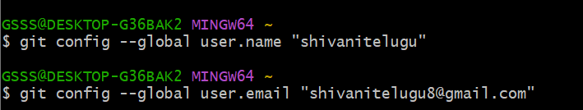
Experiments On Project Management with Git

Experiment 1:

Setting Up and Basic Commands:

Initialize a new Git repository in a directory. Create a new file and add it to the staging area and commit the changes with an appropriate commit message.

Step 1: Create a new directory
mkdir git-exp1
cd git-exp1

Step 2: Initialize a new Git repository
git init

Step 3: Create a new file
touch file1.txt

Step 4: Check repository status
git status

Step 5: Add file to staging area

git add file1.txt

Step 6: Verify staged file

git status

Step 6: Verify staged file

git status

EXPECTED OUTPUT:

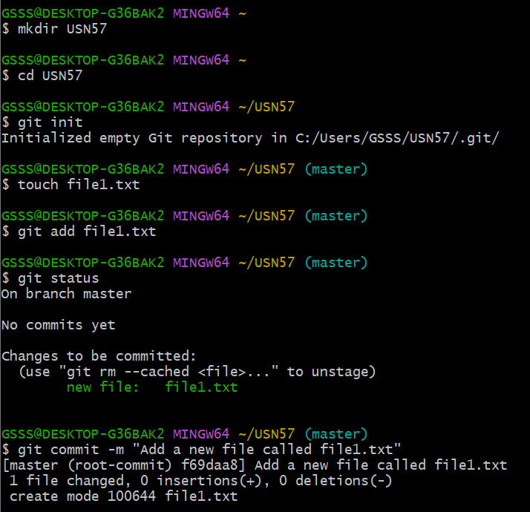
Experiment 2:

Creating and Managing Branches:

Create a new branch named "feature-branch." Switch to the "master" branch.
Merge the "feature-branch" into "master."

Step 1: Create a new branch named feature-branch

git branch feature-branch

Step 2: Switch to feature-branch

git checkout feature-branch

Step 3: Make changes in feature-branch (example)

echo "This is a feature update" >> file1.txt
git add file1.txt
git commit -m "Added feature update"

Step 4: Switch back to master branch

git checkout master

Step 5: Merge feature-branch into master

git merge feature-branch

Step 6: Verify branches

git branch

EXPECTED OUTPUT:

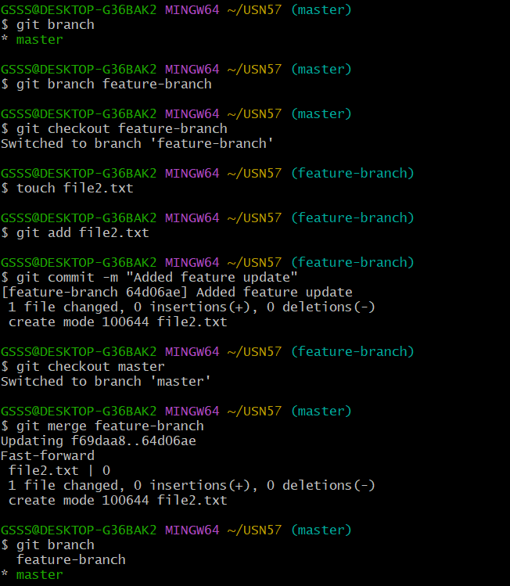

Experiment 3:

Creating and Managing Branches:

Write the commands to stash your changes, switch branches, and then apply the stashed changes.

Step 1: Check current changes

git status

Step 2: Stash the changes

git stash

Step 3: Switch to another branch

git checkout master
OR
git switch master

Step 4: Apply the stashed changes

git stash apply

EXPECTED OUTPUT:
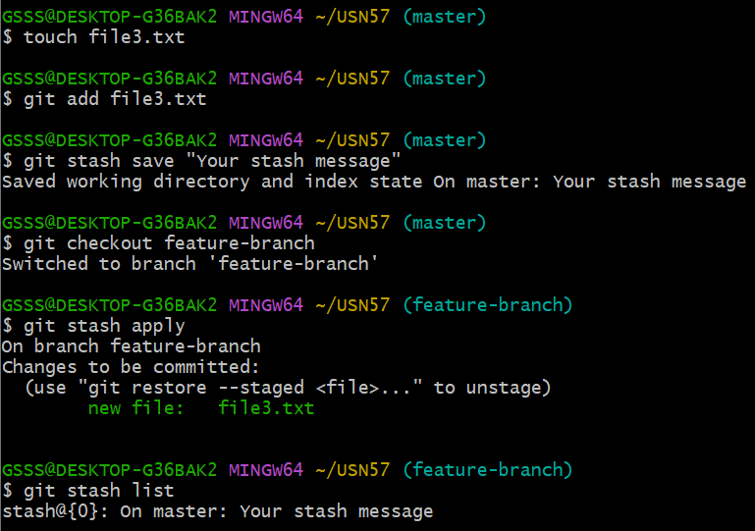

Experiment 4:

Collaboration and Remote Repositories:

Clone a remote Git repository to your local machine

Step 1: Copy the remote repository URL

Step 2: Open terminal / Git Bash

Step 3: Clone the repository

git clone https://github.com/username/repository-name.git

EXPECTED OUTPUT:

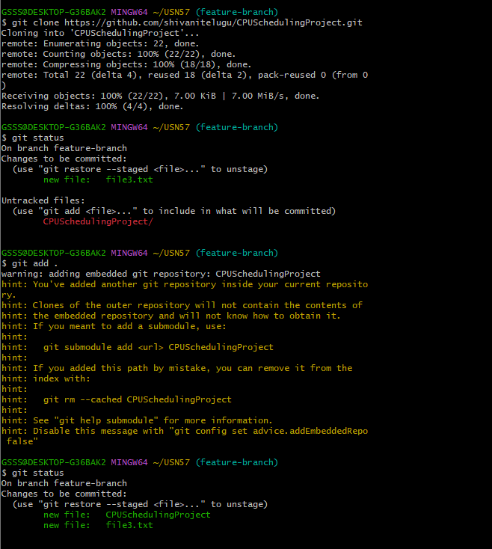

Experiment 5:

Collaboration and Remote Repositories:

Fetch the latest changes from a remote repository and rebase your local branch
onto the updated remote branch.

Step 1: Check current branch

git branch

Step 2: Fetch latest changes from remote

git fetch origin

Step 3: Rebase local branch onto updated remote branch

git rebase origin/master
(Use main if your repo uses main branch)
git rebase origin/main

Step 4: Resolve conflicts (if any)

git status
Fix conflicts → then:
git add <file-name>
git rebase –continue

git push origin <branch-name>

EXPECTED OUTPUT:

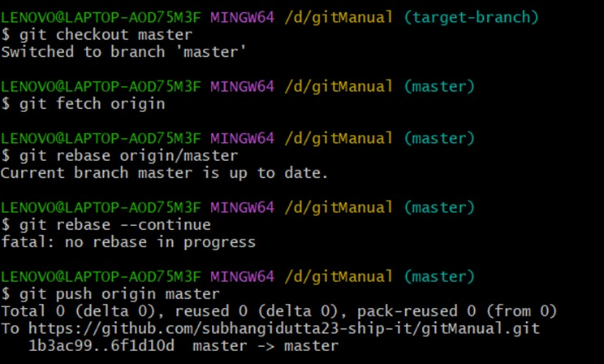
Experiment 6:

Collaboration and Remote Repositories:

Write the command to merge "feature-branch" into "master" while providing a custom
commit message for the merg

Solution:

To merge the "feature-branch" into "master" in Git while providing a custom commit message
for the merge, you can use the following command:

$ git checkout master
$ git merge feature-branch -m "Your custom commit message here"

Replace "Your custom commit message here" with a meaningful and descriptive commit message for the merge. This message will be associated with the merge commit that is created when you merge "feature-branch" into "master."

EXPECTED OUTPUT:

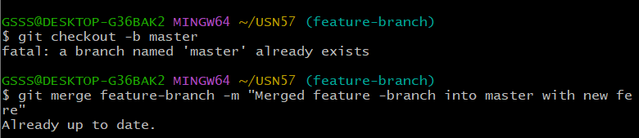

Experiment 7:

Git Tags and Releases:

Write the command to create a lightweight Git tag named "v1.0" for a commit in your
local repository.

Create a lightweight tag named v1.0 for the latest commit
git tag v1.0

EXPECTED OUTPUT:

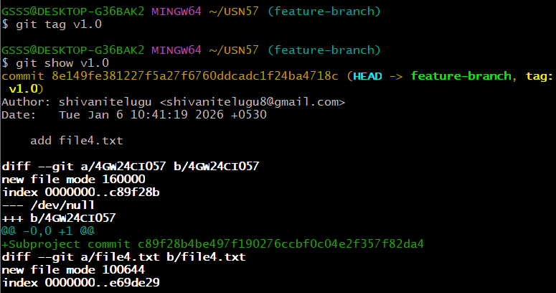

Experiment 8:

Advanced Git Operations:

Write the command to cherry-pick a range of commits from "source-branch" to the current branch.

Command to Cherry-pick a Range of Commits
git cherry-pick <start-commit>^..<end-commit>

EXPECTED OUTPUT:

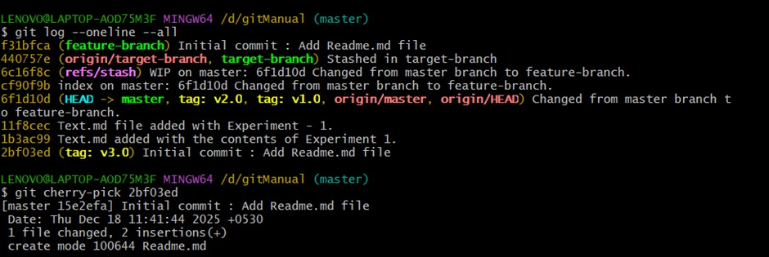
Experiment 9:

Analysing and Changing Git History:

Given a commit ID, how would you use Git to view the details of that specific commit, including the author, date, and commit message?

Command to View Details of a Specific Commit
git show <commit-id>

EXPECTED OUTPUT:

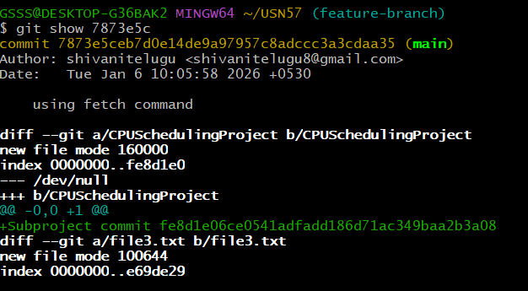
Experiment 10:

Analysing and Changing Git History

Write the command to list all commits made by the author "JohnDoe" between "2023-01-01" and "2023-12-31."

Command to List Commits by a Specific Author Within a Date Range

git log --author="JohnDoe" --since="2023-01-01" --until="2023-12-31"

EXPECTED OUTPUT:
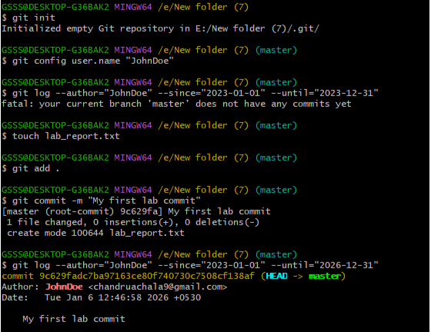

Experiment 11:

Analysing and Changing Git History

Write the command to display the last five commits in the repository's history.

To display the last five commits in a Git repository's history, you can use the git log command with the -n option, which limits the number of displayed commits. Here's the command:

$ git log -n 5

This command will show the last five commits in the repository's history. You can adjust the number after -n to display a different number of commits if needed

EXPECTED OUTPUT:

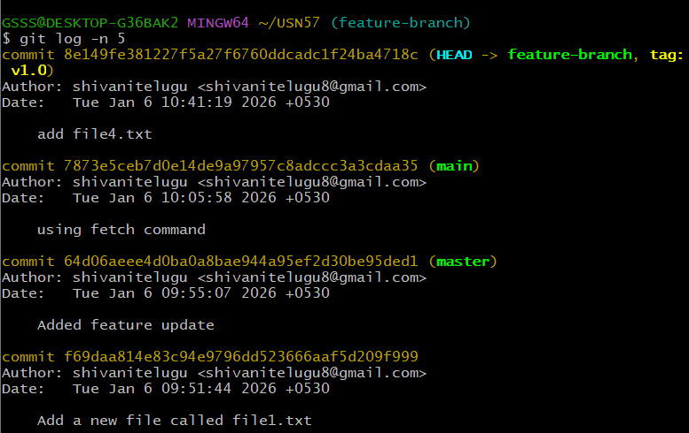

Experiment 12:

Analysing and Changing Git History

Write the command to undo the changes introduced by the commit with the ID "abc123".

To undo the changes introduced by a specific commit with the ID "abc123" in Git, you can
use the git revert command. The git revert command creates a new commit that undoes the
changes made by the specified commit, effectively "reverting" the commit. Here's the command:

$ git revert abc123

Replace "abc123" with the actual commit ID that you want to revert. After running this
command, Git will create a new commit that negates the changes introduced by the specified
commit. This is a safe way to undo changes in Git because it preserves the commit history and
creates a new commit to record the reversal of the changes.

EXPECTED OUTPUT:

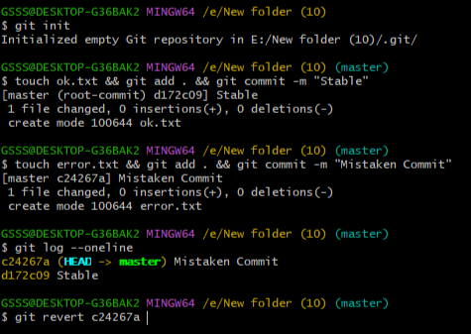

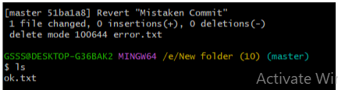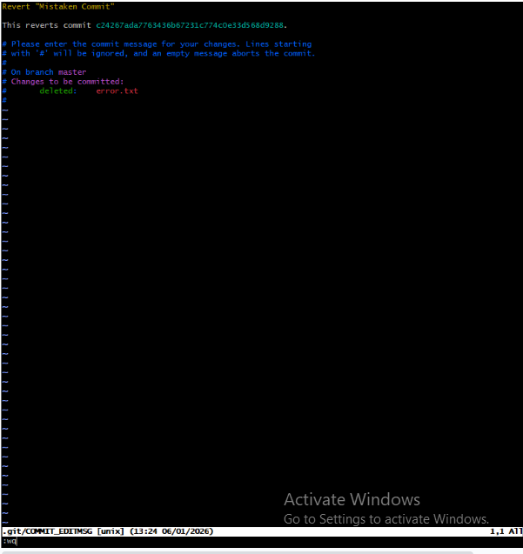
Appendix

Repository Link:

